PEER-TO-PEER LENDING PLATFORM
@CREATIVITY THINK (9483175986/7019689991)

ABSTRACT:
The Peer-to-Peer Lending Platform is a web application designed to enable users to borrow and lend money directly, bypassing traditional financial institutions. Users can request loans, offer funds, track agreements, and manage repayments, while administrators oversee users, loan activities, and resolve disputes. Built using Django, Django Rest Framework, React, Redux, and Recharts, the system provides secure, transparent, and real-time tracking of loan transactions along with comprehensive analytics dashboards for both users and administrators..

INTRODUCTION OF THE PROJECT:
Access to loans and lending is often limited by traditional financial systems and intermediaries. The Peer-to-Peer Lending Platform connects borrowers directly with lenders through a secure and efficient web application. Users can create loan requests, make offers, and track repayments, while admins manage loan activities, monitor analytics, and resolve disputes. The platform combines backend reliability (Django & DRF) with a responsive frontend (React & Redux) and data visualization (Recharts) to provide transparency and efficiency for all stakeholders..

PROJECT OBJECTIVES:

• Enable direct lending and borrowing between users
• Track loan agreements and repayment schedules
• Provide dashboards for users to monitor loans and repayments
• Enable admins to manage users, loans, and disputes
• Reduce dependency on traditional banking processes
• Support secure financial transactions and notifications
• Analyze platform activity and generate reports
• Ensure compliance and transparency in lending activities

PROBLEM OF THE STATEMENT:
Traditional lending systems involve intermediaries, higher costs, and slower processes. Many individuals and small groups lack access to quick, flexible loans. The Peer-to-Peer Lending Platform addresses these challenges by providing a direct and secure system for loan requests, offers, repayments, and agreement tracking. Users gain a faster and transparent borrowing experience, while administrators can monitor transactions and resolve disputes efficiently..

MOTIVATION OF THE PROJECT:
• Provide an alternative to traditional lending institutions
• Facilitate peer-to-peer social finance and micro-loans
• Ensure secure and transparent lending and borrowing processes
• Enable real-time monitoring of loans and repayments
• Support analytics-driven decision-making for admins and users

BLOCK DAIGRAM OF PROJECT:

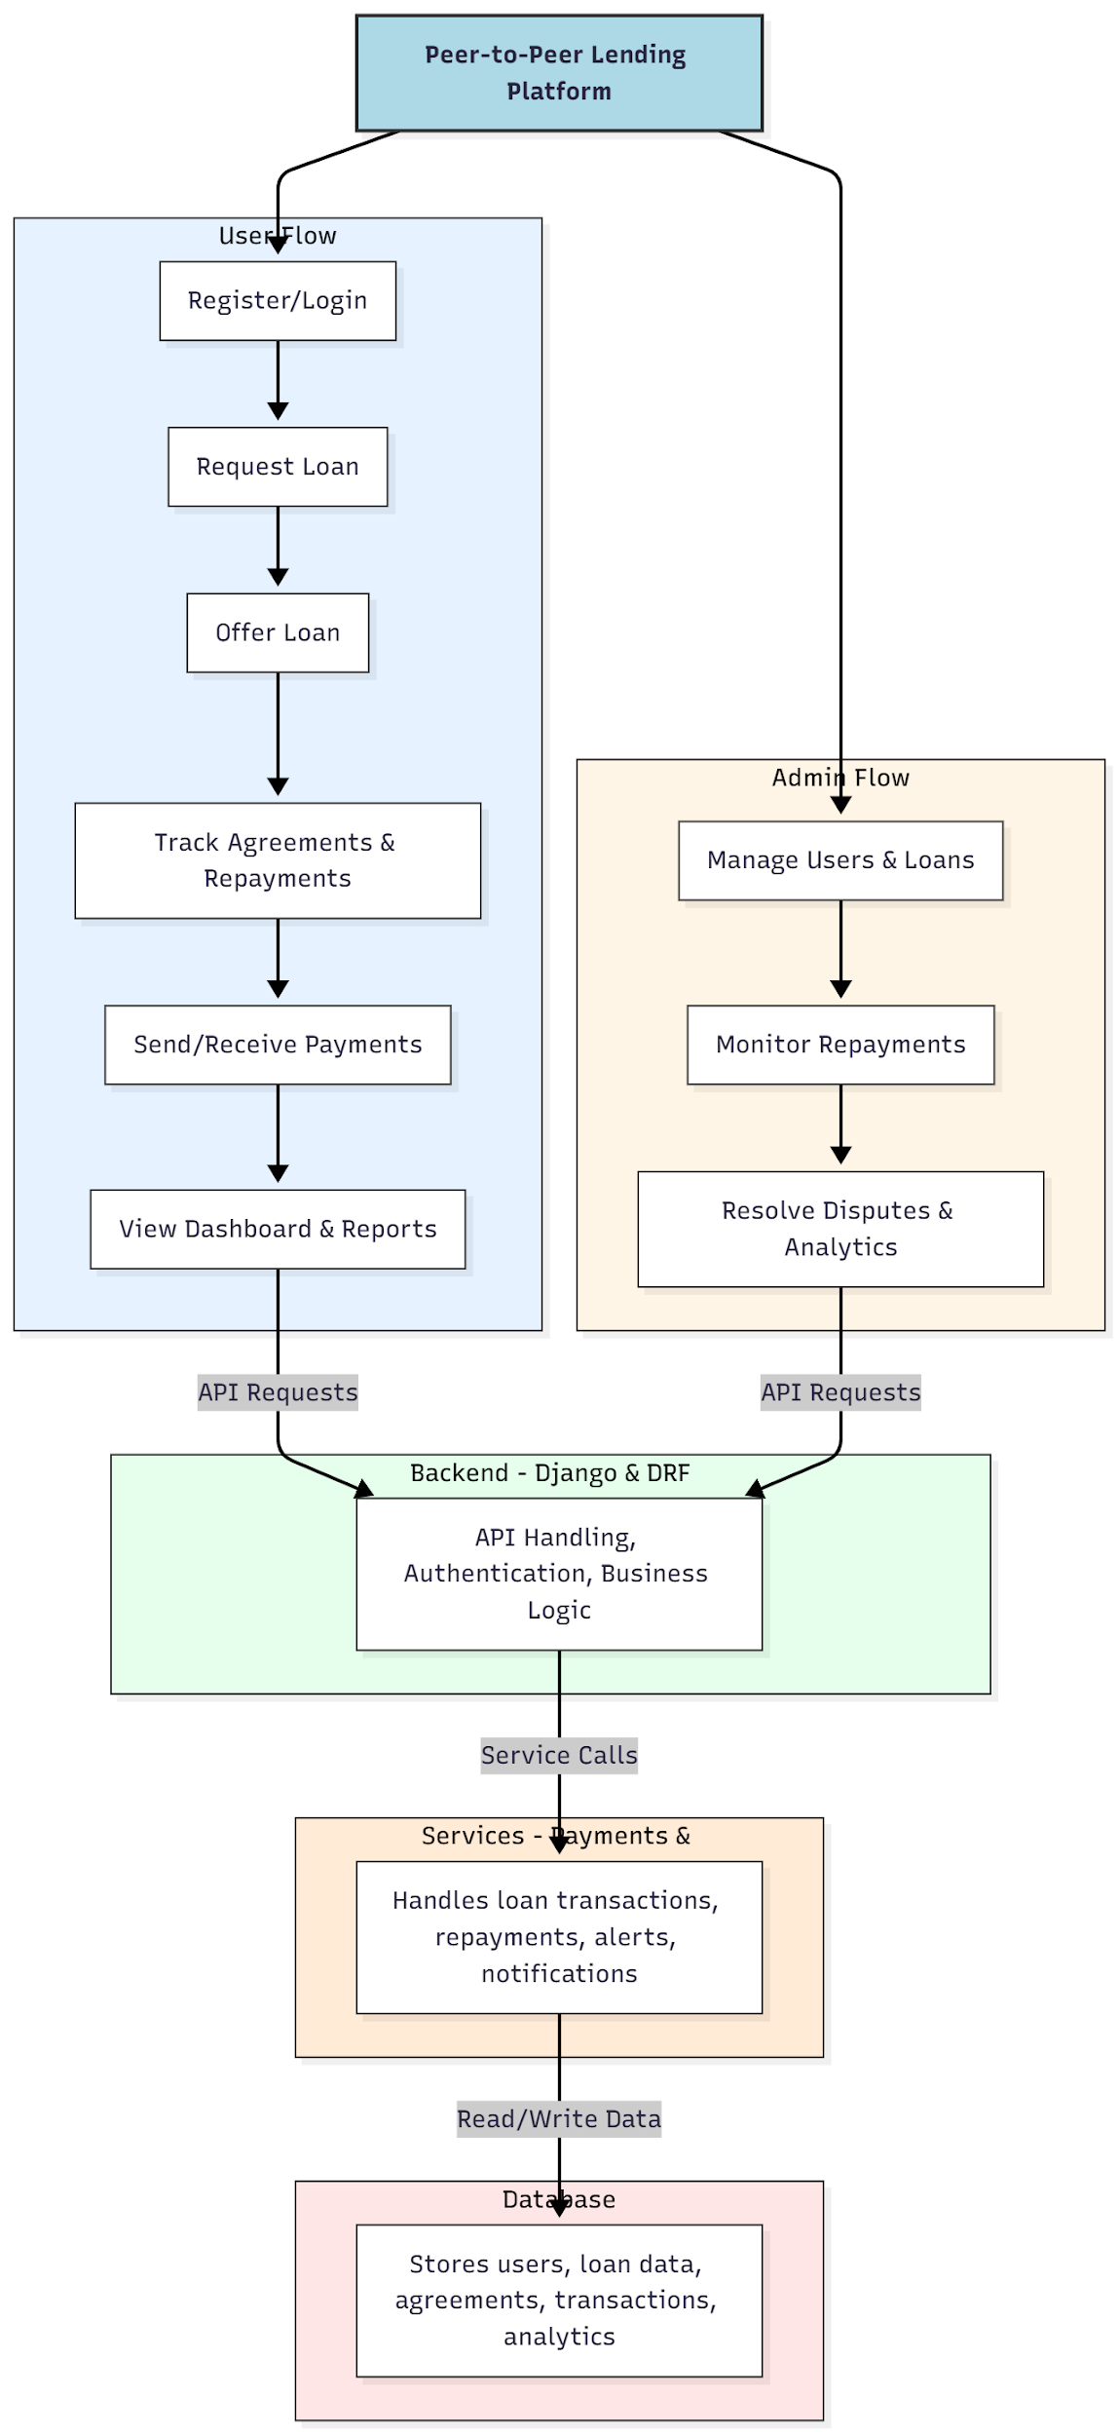

WORKING OF THE PROJECT:
Users register or log in to the platform and can request loans or offer funds to other users. Loan agreements are generated and tracked automatically, with notifications for repayments. Users can send and receive payments and view detailed dashboard analytics of all loans. Administrators monitor users and loan activities, resolve disputes, and analyze platform-wide data. The backend handles authentication, API requests, and business logic, while services manage payments, alerts, and notifications. The database stores all user, loan, and transaction data for real-time processing and reporting..

SOFTWARE REQUIREMENT:
- Backend:
  - Python 3.x
  - Django
  - Django REST Framework
  - SQLite/PostgreSQL
- Frontend:
  - Node.js and npm
  - React.js
  - Axios
- Development Tools:
  - Visual Studio Code
  - Postman (for testing APIs)
  - Git/GitHub (for version control)
- Server/Deployment (Optional):
  - Gunicorn, Nginx, or Heroku/AWS for hosting

ADVANTAGES OF THE PROJECT:

• Facilitates direct lending and borrowing between peers
• Reduces dependency on banks and intermediaries
• Provides secure tracking of loans and repayments
• Dashboard analytics for users and admins
• Dispute management capabilities
• Real-time notifications and alerts
• Transparency in loan agreements
• Efficient loan lifecycle management

APPLICATIONS OF THE PROJECT:
• Peer-to-peer lending networks
• Social finance platforms
• Microfinance and community loans
• Crowdfunding and personal loans
• Financial inclusion for small groups
• Personal loan management tools
• Loan repayment monitoring
• Analytics-driven decision-making in lending

REFERENCES:

- Django REST Framework Documentation — Django Software Foundation. Django Documentation. Available: https://docs.djangoproject.com/
- Django REST Framework. DRF Documentation. Available: https://www.django-rest-framework.org/
- React. React Official Documentation. Available: https://reactjs.org/docs/getting-started.html
- Redux. Redux Documentation. Available: https://redux.js.org/introduction/getting-started
- PostgreSQL Global Development Group. PostgreSQL Documentation. Available: https://www.postgresql.org/docs/
- MySQL. MySQL Reference Manual. Available: https://dev.mysql.com/doc/
- Git. Git Documentation. Available: https://git-scm.com/doc
- Node.js. Node.js Documentation. Available: https://nodejs.org/en/docs/
- Axios. Axios Documentation. Available: https://axios-http.com/docs/intro
- Socket.io Documentation – https://socket.io/docs/

